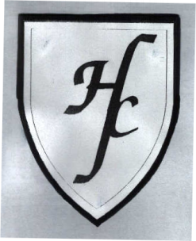
Holy Family Catholic Primary School
Hall Lane, Cronton, Cheshire WA8 5DW

Tel: 0151 424 3926 Fax: 0151 420 3177

Headteacher: Mrs J Cook-Hannah

We pray together. We play together. We learn together.
Reception Newsletter
22nd April 2016
Dear Parents/Carers,

Second week in and what a glorious week it has been. This week we have spent lots of time outdoors making the most of the sun. The children have enjoyed being able to utilise our outdoor classroom to play and learn.

Literacy
This week in Literacy the children have been learning about St. George. The children have listened carefully to the story of George and the Dragon and are able to retell the story and talk about their favourite part. Half way through the story the children helped George by creating their own wanted posters for the dragon. The children took part in a big talk to discuss what they thought the dragon might have looked like, smelt like, sounded like and felt like. They were then able to show us by drawing their dragon. I was so impressed with the children’s ideas and how so many children used their knowledge of phonics to label it.

We have also been looking at some facts about St. George’s Day:
- St. Georges Day is on the 23rd April
- St. George was a Roman solider
- He protested against the Romans
- St. Georges emblem is the English flag
- The English flag is white with a red cross

Maybe your child would like to tell you about the story of George and the Dragon or talk about some of the facts they have learnt.

Maths
Our starter activity this week has focused on recognising numbers 0-20 and being able to find one more and one less than a given number. Our main objective has been for the children to use the language of doubling, halving and sharing.

The children have been thinking about what it means to double, half and share. We have talked about doubling being when we make something twice as big. The children have used objects and their fingers to double. They have also enjoyed listening to the doubles rap (please see link below).

https://www.youtube.com/watch?v=Ik_-OAgzD-8

When it comes to halving we have talked about how when we halve something we split it into 2 equal groups. The children have looked at examples of this using objects such as pizza and cake, as well as amounts, e.g. 6 sweets split equally between 2. In this case the children have had to share the objects.

Come and See
This week we have continued sharing our good news. The children have also listened to Luke’s story of the Pentecost.

After Jesus had gone back to his Father in heaven, his friends were sad. They missed him. They felt lonely and afraid without him. On Pentecost day, they were all together in the house. Crowds of people came to Jerusalem to celebrate the feast. The friends of Jesus did not go out to join them. They stayed all together in the house. They talked about Jesus and remembered what he had told them. They began to feel different. Joy and happiness filled their hearts. It was wonderful. They knew that Jesus had kept his promise to send a new friend, the Holy Spirit. “Let’s go out and join the crowds.” Peter said. “Let’s tell them the Good News that Jesus is alive.”

The children then took a quiet moment of reflection to think about how Jesus’ friends felt through out this story.

Letters and Sounds
This week Reception have learnt 4 new phonemes: oi/ ear/ air/ ure
And 1 new high frequency word: they

We have also been focusing on reading simple sentences using high frequency words and phase 3 sounds. The children are working hard to find digraphs and trigraphs in words when reading. E.g. b/oa/t not b/o/a/t

Reading Books/RARA books
RaRa books will continue to be changed on a Monday. If your child has not finished their book please write in their diary that you wish to keep it for a bit longer.

Home reading books will also continue to be given out on a Monday. The books I choose for your child are usually chosen so that they can read them with ease. Reading at home should be a pleasurable experience and your child should approach a book with confidence. You may notice that books may be repeated. This is because the children do enjoy familiar books and by reading books they know it also helps to develop their sight vocabulary.

Snack Money
Snack money is paid on a half-termly basis. This half term snack money will be £10.50. The children, as always, are provided with a healthy snack. If snack money is still outstanding from previous terms can you please send it in with this term’s money.

Reading
Please keep up all of the good work reading at home, remembering only to spend about 5/10 minutes per evening on any task. Your children are making excellent progress through your continued support and encouragement at home.

Have a lovely weekend,
Miss Smith, Ms Connolly & Miss Langton

Dates for Diary
Rec/ Y1 trip– 19th May 2016

We Love to Read!
This week in Reception we have read George’s story...
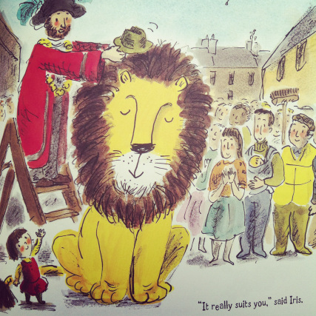

^{What was your favourite part?}
If you have a book at home that you love to read maybe you would like to bring it in to share with the class at story time.

