Holy Family Cronton

Catholic Primary School

Policy

for

Spiritual & Moral Development

MISSION STATEMENT

Following in Jesus’ footsteps we will:

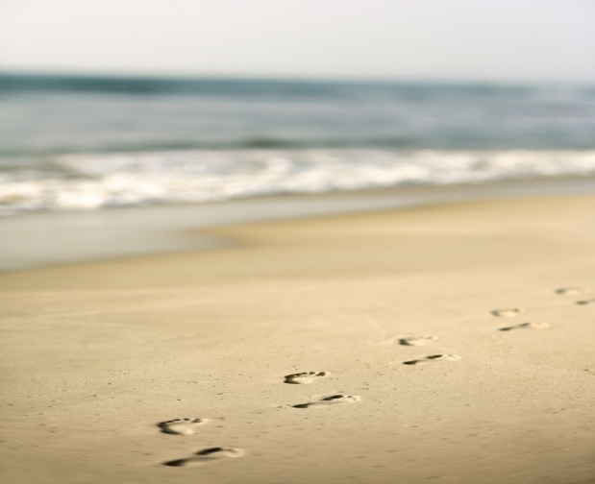

Pray together, Play together, Learn together.

In fulfilling our Mission Statement we aim to:

Pray together:

- Through our family and community of faith we strive for all to hear the message of God.

- Through the promotion of the Christian values of love, acceptance and respect for all, we will provide opportunities for all to develop an awareness of God’s presence in themselves and in others.

- Through the teachings and practice of our faith we will provide opportunities to respond to the word of God through collective worship, celebration and quiet reflection.

Play together:

- Through the development of excellent relationships in our school community we will strive to ensure all experience mutual respect, acceptance and love.

- Through fun filled activities, projects and social events we will provide opportunities to promote community cohesion and togetherness.

- Through our creative curriculum we will strive for all to seek excellence and experience enjoyment.

Learn together:

- Through the provision of a stimulating, well-balanced, forward thinking, diverse curriculum we will provide opportunities for all to develop an awareness of themselves, others and the world in which we live.

- Through inspirational, innovative, holistic teaching we will seek to create learners who aspire to succeed.

- Through the promotion of learning and equality for all we will strive to create independent, life long learners.

Introduction

The promotion of pupils’ spiritual, moral, social and cultural development provides the ‘why’ of education: it is an essential ingredient of a successful Catholic school.

The statutory requirement that schools should encourage pupils’ Spiritual, Moral, Social and Cultural development was first included in the Education Reform Act 1988. The Act began as follows:

‘The curriculum for a maintained school (must be) a balanced and broadly based curriculum which:
a) promotes the spiritual, moral, cultural, mental and physical development of pupils at the school and in society, and
b) prepares such pupils for the opportunities, responsibilities and experiences of adult life.’

The Act clearly recognised that there is more to life than achieving high standards in academic subjects. The task was described as:

‘…the training of good human beings, purposeful and wise, themselves with a vision of what it is to be human and the kind of society that makes that possible’.

Spiritual, Moral, Social and Cultural Development is at the heart of what education is all about – helping pupils grow and develop as people.

Opportunities for pupils to experience and learn about Spiritual and Moral Development in our school

It is an expectation at this school that all staff, in all subjects, can and should make a contribution to the Spiritual, Moral, Social and Cultural Development of pupils through the taught curriculum and through the use of appropriate teaching and learning strategies e.g. discussion, reflection, pupil participation, circle time etc

Spiritual Development

Spiritual education helps pupils to acquire insights into their personal existence which are of enduring worth. It is characterised by reflection, the attribution of meaning to experience, valuing a non-material dimension to life and intimations of an enduring reality. “Spiritual’ means ‘of the spirit’. Spiritual development, therefore, concerns the development of the essence of a unique child. In the Catholic tradition, spiritual development is related to growth in faith. However Spiritual is not synonymous with ‘religious’; all areas of the curriculum may contribute to pupils’ spiritual development.

Spiritual development is concerned with how an individual acquires personal beliefs and values, especially on questions which are “at the heart and root of existence.” It is therefore also about what a school provides – through its curriculum, through Collective Worship, through its ethos and climate – to help individuals to make sense of these questions and about what it does to help form pupils’ response to life, to their various experiences and even to questions about the universe. Spiritual is very much at the heart of life.

Spiritual Development is promoted throughout the whole curriculum by providing pupils with opportunities and encouragement to:

- Reflect on themselves, others and life’s fundamental questions (Come and See, literacy, science, PSHE)

- Exercise intellectual curiosity – testing their beliefs against others’ and exploring sameness and differences (study of other faiths, geography, history)

- Study and discuss – the insights of the great teachers and philosophers

- Experience awe and wonder – to be moved by nature and by excellence in human achievement.

- Exercise imagination and intuition – in creative pursuits and in forming theories in their academic work and daily life.

- Discuss and debate – insights, beliefs, ideas, emotions, feelings and experiences (Come and See circle time, PSHE)

- Reflect and respond to God’s presence in prayer, worship, reflection and during Sacramental preparation.

The development of children’s spiritually implies that this is an area in which they can make progress. This may not be linear but may include the following steps:

  - Recognising the existence of others as independent from themselves.

  - Becoming aware of and reflecting on experience.

  - Questioning and exploring the meaning of experience.

  - Understanding and evaluating a range of possible responses and interpretations.

  - Developing personal views and insights.

  - Applying insights gained with increasing degrees of perception to one’s own life.

  - Personal response to questions about the purpose of life and to the experience of beauty, love, pain or suffering.

Moral Development

Moral Development is about the building, by pupils, of a framework of moral values which regulates personal behaviour. It is about the development of pupils’ understanding of society’s shared and agreed values. All adults in the school are aware that children learn by example. All adults therefore aim to demonstrate respect in their relationships with each other and with the children in their care. This is demonstrated informally through daily interactions with colleagues and pupils. The School Council recognises the value of pupils’ opinions and good behaviour is rewarded.

Moral education helps pupils to acquire knowledge, understanding, intentions, attitudes and behaviour in relation to what is right or wrong.

Moral development is concerned with understanding the difference between right and wrong and with committing ourselves to doing what is right because we want to do right.

People who are developing morally listen to their conscience, the inner sense informed by their upbringing, experiences, faith and religious beliefs and are prompted to do what is right out of love for others, respect for ourselves and regard for the world in which we live.

Moral Development in our school is promoted throughout the whole curriculum and expressed in our agreed values. Pupils are provided with opportunities and encouragement to:

- think critically – understanding the difference between fact and opinion, informing themselves about key social, political, economic and legal issues, evaluating evidence for and against different sides in a debate and making informed decision about their own positions (literacy, citizenship, history)

- acquire and develop appropriate values and attitudes – those that enhance willingness to participate and help others to participate where necessary

- discuss and debate – exercise reason in debate and develop an understanding of the powerful influences on public opinion represented by the political parties, the church and other faith communities, the media and other organisations.

- Participate in democratic processes such as school councils, committees and discussion groups.

- Participate in the life of the wider community through volunteering and charity work.

At Holy Family School we aim to create a secure community in which the Gospel Values of Freedom, Justice and Love permeates every aspect of its life and work.
Holy Family School is dedicated to enabling all members of our school community to grow in faith through a deepening knowledge of creation and revelation and to live that faith within our school community, at home, in the parish and in the wider world.

This Policy should be read in conjunction with the School Mission Statement, the RE Handbook and the ‘Come and See’ scheme.

