Year 2
Coffee Morning
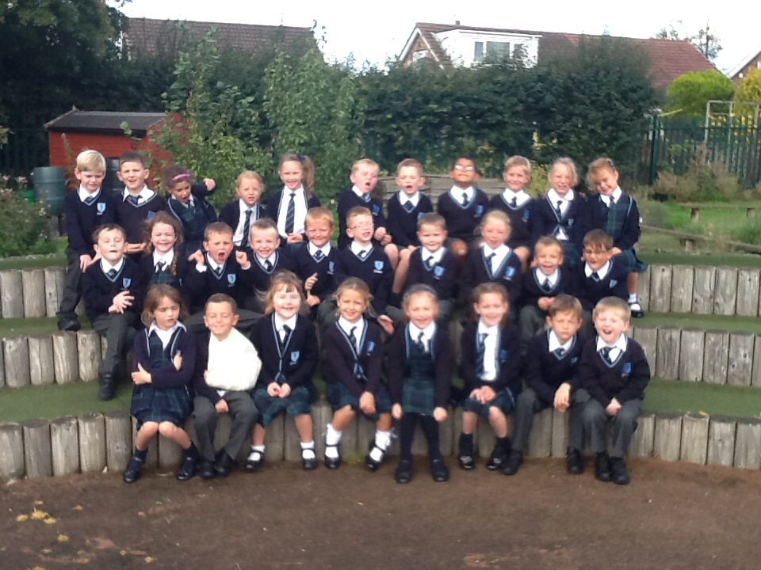
Welcome

We pray together, play together and learn together.

Wednesday 30th September

Dear Parents/Carers,
Welcome to Year 2! We are so proud of how the Year 2 children have settled in. We have an exciting year ahead of us and we look forward to sharing this learning journey with all the children and their parents.
Topics for Autumn Term
R.E. Come and See | Beginnings, Signs and Symbols, Preparing,  Judaism
Science | Materials-Uses of everyday materials and Changing Materials.
P.E. | Games, Gymnastics, Dance
Topic | The U.K. and London.  Significant People and Events in History-Remembrance Sunday, The Great Fire of London, Guy Fawkes,
English | A Midsummer Night’s Dream-William Shakespeare, Traditional Stories,  Class Reader-Owl Babies  Class Poem-Where the Fairies are by David Harmer
PSHCE | Mrs Featherstone will focus on ‘Personal, Social, Health and Citizenship Issues every Wednesday afternoon.

General Information
Homework
Monday | Spellings given out (a list for the term has already been given)
Tuesday | Reading books changed  Ra,Ra,Ra books changed (in the hall at 8.40)
Wednesday
Thursday | Reading books changed
Friday | Spelling Test  Literacy and Numeracy homework given (to be handed in by the following Thursday)
Continuous | Reading either school books or own books each night.

Spellings/Phonics
We practise the spellings daily in class as well as Letters and Sounds. This term we are revising Phase 3,4 and 5 from Year 1. The spellings are key words form Letters and Sounds phases. The spelling test is given in a very relaxed environment. I do not want the children to worry about them at all. We practise the spellings before the test as a reminder for them. It is not a pass or fail test but simple a way to encourage the children to spell key words correctly in their writing.

Reading
All children should spend about 10 or 15 minutes a day reading their school books. It is vitally important that at this age parents read with their child.

Top tips-Discuss the story and illustrations with your child, as this will develop their understanding of the text and comprehension skills. You could read alternative pages with your child. By doing this you are modelling how to read, how to use punctuation and expression in your voice at appropriate points of the story.

Ra, Ra, Ra- the children can choose a fiction and non-fiction book to share at home with their parents. Ra,Ra,Ra books are for parents to read to their children, however, you may find that your child may want to read it by themselves or to you. Don’t worry if your child finds it difficult to read them as they are not scheme books or ability based. They are simply for you and your child to share and enjoy together.

Reading for pleasure- I know you don’t always get the opportunity to read to your child as there is so much to do before bedtime! With this in mind I would like to encourage everybody on a Friday to take the time to read a story to your child. I will be ‘tweeting’ and sharing books on the school websites that you may like to use. You may have a favourite book from your childhood that you would like to read to them. The libraries are a fantastic resource to use and your child may enjoy choosing the next book for you to share. Books with chapters are a good idea. They may also like to choose books form the same author. It would be a lovely opportunity for children to experience a wealth of literature which they mightn’t be able to read themselves. I would love to hear about what books you are reading together at home so let me know in your child’s reading diary. I also encourage the children to bring into class books or magazines from home that they would like to read during Guided Reading sessions in school.

Mathletics, Reading Eggs and Spellodrome.
Please encourage your child to use these websites at home. They are a fantastic resource that the school purchase each year. The children should all have their passwords by now but please let me know if your child does not have theirs.

P.E.
The children will have 2 hours of P.E. every week. This amount or regular exercise is vitally important: therefore, please ensure that they have full P.E. kit in school at all times. If your child doesn’t have a P.E. kit, they will be offered a school kit from a bank of spares that parents have donated. Our P.E. days are Tuesday and Thursday.

Uniform
Please make sure that your child has the correct school uniform and that all items of uniform are clearly marked with your child’s name to prevent items getting lost. Also, please ensure that long hair is tied back at all times.

Water Bottles and Snacks
Please encourage your child to bring a water bottle into school. This will need to go home each night to be washed and returned filled with water the next day. They can also bring in a snack to be eaten during break time. Please note that we do not allow chocolate or sweets for snack.

Art T-shirts
The children will need an old shirt or t-shirt to cover their clothes during art lessons.

Punctuality/Absence
The children should line up at 8.55 on the playground unless it is raining heavily, in which case, classroom doors will be opened at 8.45. It is your responsibility to supervise them up until this point. Any child arriving after the class have entered the classroom at 8.55 needs to go to the main door to be signed in by Mrs Glanvill or Mrs Campbell. If for any reason your child is absent from school, please contact us to let us know. If we do not hear from you, then Mrs Featherstone, our Learning mentor, will ring to find out why your child is absent. If you need to collect your child at any time in the day for an appointment, could you please report to the office and your child will be collected from their classroom.

Behaviour and School Golden Rules
Do be gentle- Don’t hurt anyone
Do be kind and helpful- Don’t hurt people’s feelings
Do listen- Don’t interrupt
Do work hard- Don’t waste your or other people’s time
Do look after property- Don’t waste or damage it
Code of Conduct
- Correct school uniform must be worn unless there is a particular explained reason.
This includes P.E. kit.
- Children should not run inside school. They should move around the building in a safe and sensible manner.
- At break time, children may eat a piece of fruit or a healthy snack. Sweets and chewing gum are not allowed in school.
- After leaving the building at lunchtime, children should not re-enter the school building without permission.
- Children will show respect to all adults in the school.
- No abusive language is tolerated.
- Jewellery, apart from a wrist watch, is not permitted.
- Nail varnish should not be worn.

Golden Time
Children will gain their right to participate in a Golden Time activity by demonstrating an excellent attitude to their work, peers and staff. The children will lose minutes if they break the Golden Rules. They will spend their lost minutes reflecting on their behaviour.

Praising and Rewarding
Children are praised daily for their hard work and good behaviour. As well as Golden Time on a Friday we also have Certificate Assembly, stickers, Headteacher Awards and a termly achievement assembly in which, amongst other things, attendance and punctuality are also celebrated. In Year 2 we put coloured stones in a jar to reward good behaviour, if the jar is full by Thursday afternoon we have a Thursday treat!

Red and Yellow Cards
Staff may issue a red or yellow card as another way of reinforcing school rules. Red and Yellow cards can be used throughout the day and at dinner time when children fail to comply with the behaviour code. Yellow cards will be issued after a verbal warning for minor incif=dents. Red cards will be applied for more serious incidents such as physical harm, insolence etc. A yellow card will result in a ten minute suspension from playtime, and a red card will result in the child missing the remaining playtime that day and the next. A letter home will be sent with the issue of a red card.

Questions and Appointments
If you do have any questions or any matter you would like to discuss about your child please do not hesitate to contact me in school. You can contact me via email, phone call or make an appointment to speak with me. However, I am always available after school if you would prefer to speak to me then. It is however, very hard to discuss issues at 8.55 am when I am collecting the children from the playground.

"They may forget what you said but they will never forget how you made them feel." -- Carol Buchner

Our aim is for your child to learn and to reach their full potential in a safe, secure and above all a happy environment. Their happiness is our main concern. If they are happy and feel secure then everything else will come easily to them.

Many thanks,
Mrs Edge and Mrs Davison.

Tell me and I forget. Teach me and I remember. Involve me and I learn." -- Benjamin Franklin

