WELCOME TO HOLY FAMILY CATHOLIC PRIMARY SCHOOL

Holy Family Catholic Primary School
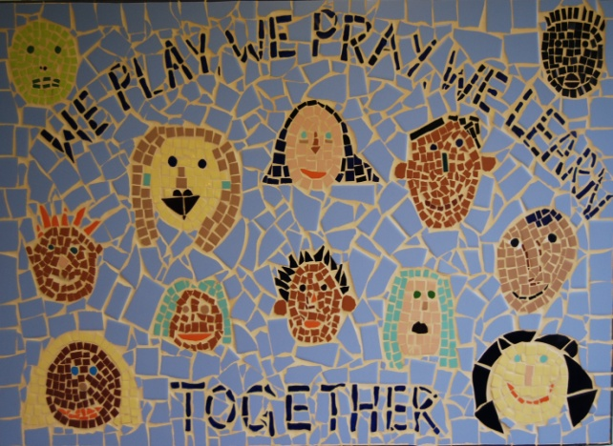
Hall Lane
Cronton
Cheshire
WA8 5DW
Tel: 0151 424 3926
Fax: 0151 420 3177
Email: holyfamilycronton@knowsley.gov.uk
Web: www.holyfamilycronton.co.uk
Headteacher: Mrs J Cook-Hannah
Chair of Governors: Mrs M Raymond

Dear Parents and Carers,

Welcome to Holy Family School website
Holy Family School is an ‘outstanding’ Catholic School as judged by our last Ofsted Inspection in September 2011 and our Religious Education Inspection in November 2011 by Liverpool Archdiocese.
I hope the information contained in this website provides you with a good insight into Holy Family School: our ethos, our aims and our vision.
At Holy Family, we strive to develop a true partnership with all our parents and carers – a relationship of mutual trust and respect. In this relationship we work closely with our parents to develop the very best in all our children; to discover their talents and to help them develop to the fullest.
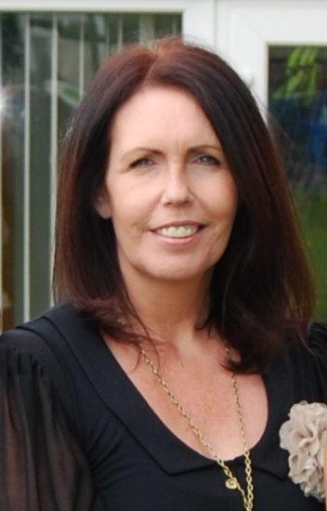
We work extremely hard to provide our children with a stimulating, broad, enriching curriculum; one that helps to prepare them for their future. We want children to want to come to school; to enjoy learning; to develop confidence – to be happy! Staff throughout the school, place a huge emphasis on Personal, Social and Emotional Development.
If you would like to visit the school, we have an ‘Open Evening’ every year when prospective parents are very welcome to visit. Parents / Carers are also welcome to visit the school outside of our Opening Evening. Please contact the school and speak to Mrs Glanvill or Mrs Campbell who will be only too happy to arrange an appointment.
I look forward to welcoming you and your child into ‘Our Family’ as we embark on what we hope is a long and happy journey.

Yours sincerely
Mrs J. Cook-Hannah
Headteacher

