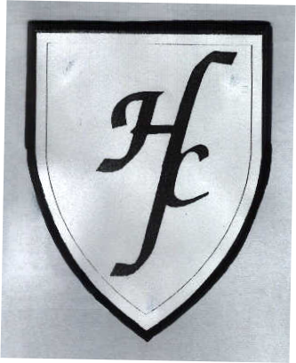

HOLY FAMILY CATHOLIC PRIMARY SCHOOL

Key Stage 2 Results 2015

 | L4+ | L5+ | L6 | 2 Lvls Progress | +2 levels Progress | 2014 |  | 2013
 |  |  |  |  |  | L4+ | L5+ | L4+ | L5+
Reading | 90% | 68% | 0% | 94% | 26% | 97% | 66% | 97% | 52%
Writing | 90% | 45% | 0% | 90% | 23% | 93% | 41% | 93% | 52%
Maths | 90% | 68% | 13% | 94% | 39% | 93% | 59% | 100% | 69%
R+W+M | 90% | 39% | 0% |  |  | 87% | 30% | 93% | 48%
Spelling and Grammar | 94% | 81% | 0% |  |  | 83% | 66%

Key Stage 1 Results 2015

 | L2+ | L3 | 2014 |  | 2013
 |  |  | L2+ | L3 | L2+ | L3
Reading | 97% | 55% | 90% | 48% | 90% | 40%
Writing | 97% | 28% | 97% | 28% | 83% | 27%
Maths | 100% | 45% | 93% | 48% | 97% | 37%
 | Working At (WA) |  | Working At (WA) |  | Working At (WA)
Y1 Phonics test | 67% |  | 87% |  | 81%

