We pray together, play together, learn together.

Reading Quality Mark Tuesday 28th June

Dear Parents/Carers,

As you know here at Holy Family we love to read! Throughout this year we have been hosting a variety of opportunities and events for the children to develop their love for reading. We believe that a love of reading and story is woven into our curriculum however this year we have had lots of experiences to enrich this with the children. A local poet and author Paul Delaney returned to school several times this year and many children enjoyed his stories and poems that much they bought copies of their favourite books. Year 6 went to the Philharmonic Hall to hear Michael Rosen recite his poetry and had a great day with lots of laughing! The whole school watched the film Paddington Bear at our cinema day and then compared the film to the book. Knowsley Library service also came in as part of National Story Telling week and retold stories from different cultures with puppets and song.

This terms events:

Charles Dickens and Beatrix Potter
The children have been introduced to classic British writers Charles Dickens and Beatrix Potter. In Year 2 and Key Stage 2 classes each studied a Charles Dickens novel, discussing themes and characters that we all know so well. In Reception and Year One the children researched and read books by Beatrix Potter, learning all about the tale of naughty Peter Rabbit!

Paul Delaney
Local author and poet Paul Delaney has been in again this term to work with Years 6 and 3 writing poetry for ‘The Widnes Primary Schools’ Poetry Festival. He said that he was very impressed with the children’s writing skills. He chose six children to represent our school at the poetry festival. Once again our children at Holy Family have made us proud with their enthusiasm and good behaviour they show to visitors.

D.E.A.R
Every Friday classroom doors will be open from 8.45 am until 9.15am for the big ‘DEAR’ (Drop Everything And Read).
Children can come into school to read their own book or a class book from 8.45-am -9.15am.
Parents and grandparents are welcome to come into class to share a book with their child.
Teachers will also be joining in with DEAR. Children will need to be in school by 8.55am or they will be marked as late.
Could we ask that parents please remain with their child until school starting time of 8.55am whether this is in class or on the playground.

Swap Shop
There will be a book swap stall at Family Fun Night for children and adults. A good excuse to find a new summer read. Please start to send in any unwanted books as soon as possible.

Outdoor Summer Read Event
On Thursday 14th July at 2.30pm we will be having our ‘Summer Big Read’ event (weather permitting). This will be held outdoors and parents/carers and grandparents are invited to come and join in reading with their child. You will need to bring a picnic, blankets and books you love to read.

Alice in Wonderland
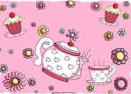
To celebrate 150 years since Alice in Wonderland was written, Reception, Year 1 and Year 2 will be having a Mad Hatter’s Tea Party on Thursday 14th July during school time. For this event please can we ask that all children bring in a funny hat to get into the spirit of the madness! Thank you!

Cinema Event
Following the success of our cinema afternoon we will be hosting another one this summer. We will be watching the original Jungle book on Wednesday July 20th at 1.30pm and eating popcorn together as we share in this classic tale by Rudyard Kipling.
School Website

www.holyfamilycronton.co.uk
Our website is in the process of being updated with information about reading events and any useful information for children and parents. These dates will also be showed in the newsletter and through the Parent App.

Knowsley Library Summer Read challenge
Knowsley Library summer reading competition runs throughout the holidays. It is a good excuse to take your child to visit and support Knowsley Library and widen your child’s reading selection. www.knowsley.gov.uk/pdf/knowsley-news-issue-44.pdf

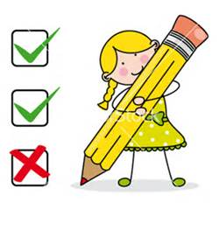
Parent Questionnaires
I have given out a reading questionnaire for parents. I would be most grateful if I could have them completed and returned by this Monday 4th July. This will help me to plan other events and reading opportunities for the children and parents to enjoy. The children have also been given a questionnaire to complete in class.

Book Tree
Please remember to visit our Book Tree at the front entrance. Please feel free to borrow a book from the basket. However, we would be grateful if you would remember to bring it back.

Stuck for a book?
If you are stuck for ideas for a good book to share with your child, Marks and Spencer’s have a lovely collection of children’s classics at the moment which Year 2 have been reading in class. These include, Black Beauty, The Secret Garden, Oliver, Treasure Island , Alice in Wonderland and Peter Pan. We also have a book review on our website.

Tatton Park
If you love Roahl Dahl then Tatton Park this summer is the place for you. They are holding a variety of events based on his best loved books. See their website for the full list of events and dates.
www.tattonpark.org.uk/events_at_tatton_park

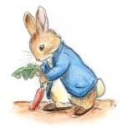
Speke Hall
Speke hall is well worth a visit this summer. They have a host of summer reading events. To celebrate 50 years of Beatrix Potter, Speke Hall will be hosting a Peter Rabbit fortnight from 27th -3st1 July and 2nd-7th August. Particularly relevant for Reception Year One as they have been learning about her and her most famous characters.

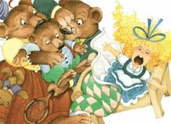
On Wednesday 10th August at 7.00 pm-10.00 pm there is an outdoor theatre event based on Gulliver’s Travels. Join The Pantaloons for a hilarious journey through fantastical kingdoms!

On Saturday 28th August 11.30am – 12.30am ‘The Bookworm Players’ return to Speke Hall with a fantastic outdoor theatre show based on the Traditional Tale ‘Goldilocks and the Three Bears’. Bring the family and enjoy this classic tale of bears, beds and porridge.
www.nationaltrust.org.uk/speke-hall-garden-and-estate/whats-on

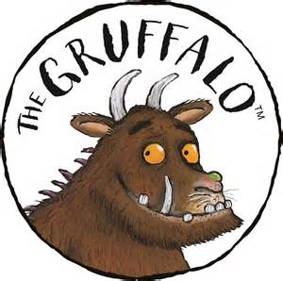
Delamere Forest
Follow The Gruffalo and Stickman on a nature trail around Delamere Forest. You can explore the forest, build dens, go on a nature hunt and enjoy a picnic all through their love of Julia Donaldson stories.
www.nationaltrust.org.uk/speke-hall-garden-and-estate/whats-on

Please keep checking Parent App, Twitter and the school website for more information.
“So please, children please, we beg, we pray,
Go throw your TV set away,
And in its place you can install
A lovely bookshelf on the wall.
Then fill the shelves with lots of books.”
Roald Dahl,
Charlie and the Chocolate Factory

Yours Sincerely,
Mrs Edge

