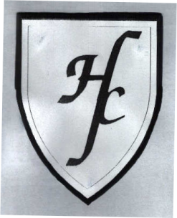
Holy Family Catholic Primary School
Hall Lane, Cronton, Cheshire WA8 5DW

Tel: 0151 424 3926 Fax : 0151 420 3177

Headteacher : Mrs J Cook-Hannah

We pray together. We play together. We learn together.

Dear Parents / Carers, 1/12/2017

Well ‘Hello December!’ The children are very excited that we have now started the countdown to Christmas! At the beginning of the week, there was a letter sent out informing parents of all the up and coming events going on in the school including our annual trip to the Brindley! The children have, once again, been working really hard on their singing! We are so proud!

English
This week we received a special letter from Father Christmas! When the letter was delivered to the office we had strict instructions on how to open it. We had to wait for 1 minute for the magic to happen and then we were able to open it. Once the minute had passed, we opened the magical letter. Father Christmas explained to the children that he had been watching them whilst they were in school and was so impressed with their singing! We described how we felt waiting to open the letter. The children used some fantastic adjectives to describe their feelings! We then started talking about how we have to wait for Christmas and Mrs Evans told the nativity story to the children. The children were able to recognise the story from their nativity play last year. For the children’s Big Draw Mrs Evans asked the children to draw the Nativity scene.
Maths
This week in Maths we used pictorial representations to create number sentences. The children are able to create their own number stories using the pictorial representations and use those numbers to complete the part-whole model. We spoke about the equals sign not needing to be at the end of the number sentence. This is quite a hard concept for the children to grasp so we will be working on more of this next week. Eg 4+6=10 10=4+6
Letters and Sounds
As mentioned the week before last, we are now starting to work backwards through Phase 3 and are focusing on particular sounds that were identified through assessments. The sounds we have focused on this week are: oo, ar, or Words containing these sounds are moon, zoo, park, shark, fork, sport.
Snack Money
Snack Money is £16 for this half term. Many thanks if you have already paid.
Posada
Thanks to all the parents who have sent in photographs of children who have already taken the Posadas home. The children love sharing their photographs in class.

Packed Lunches
As mentioned in the school Newsletter last week, children are no longer able to swap between school dinners and packed lunch on a daily basis. If you would like your child to change, two weeks’ notice must be given in writing.

Thank you for your continued support.

Miss Cook and Miss Langton

