**Holy Family Catholic Primary School**

**Hall Lane**

**Cronton**

**Nr Widnes**

**WA8 5DW**

**0151 424 3926**

**Headteacher: Mrs J Cook-Hannah**

**www.holyfamilycronton.co.uk**

[**holyfamilycronton@knowsley.gov.uk**](mailto:holyfamilycronton@knowsley.gov.uk)

Twitter@HFCronton

**Weekly Newsletter**

**Friday 29th June 2018**



**Following in Jesus’ footsteps…**

**We pray together**

**We play together**

**We learn together**







|  |
| --- |
| Come and See  http://www.educationcommission.org.uk/SiteImages/107.jpg |
| As part of our RE work on other faiths in Come and See, the children explored the Hindu Faith.  Children have had a fantastic two days working with Prags learning about Hinduism.  We believe giving children the opportunity to learn about other cultures and faiths, particularly in today’s climate, is so important.  The activities covered food tasting, traditional dancing, henna application (Y5/6) and Rangoli artwork to be displayed in school.  The cost to the school for the two full days is £900 but we have only received half the contributions towards this.  Our school budget is becoming increasingly tight and we would not want to cease these lovely enhancements to the curriculum but we really do need your support.  We have asked for £5.00 contribution per child and really do hope you can support us with this by making your donation through Parent Pay.  Please check Twitter to see the lovely photos taken.  Many thanks  Mrs Hannah |
| Our Value next week is respect  Please speak to your child/ren about the importance of this value.  Respect 1.jpg |

**Our School Prayer**

Jesus, Mary and Joseph bless my family at home,

Jesus, Mary and Joseph bless my family at school,

Jesus, Mary and Joseph bless all the families

of the world.

Amen

|  |  |
| --- | --- |
| **[Image result for time to shine](http://www.bing.com/images/search?q=time+to+shine+pictures&id=5617E7635E9C7DAE9ACC0A860BBEA206FD876DCF&FORM=IQFRBA)** | |
| **Class** | **Star of the Week** |
| Reception | Lucas |
| Year 1 | Kai |
| Year 2 | Nathaniel |
| Year 3 | Matthew |
| Year 4 | Martha |
| Year 5 | Finn |
| Year 6 | Alex |
| **The Star has been awarded to our children who have shown the value of the week.**  **Well done to the children who were chosen last week.**  star of the week proud.jpg | |

|  |  |  |  |
| --- | --- | --- | --- |
| **attendance 1.png**  **Attendance for week ending 22nd June 2018** | | | |
| **Year** | **Attendance** | **Rating** | **Weeks Won** |
| R | 97.3% | GREEN | 8 |
| 1 | 98.7% | GREEN | 4 |
| 2 | 95.5% | AMBER | 5 |
| 3 | 92.7% | RED | 5 |
| 4** | 100% | GREEN | 8 |
| 5 | 96.5% | AMBER | 4 |
| 6 | 92.7% | RED | 1 |
| **Whole School: 96.6%**  **National average is 96.3%**  **Well done**  **\*\*THREE classes were below the national average**.**  Well done Y4 you will each get an ice pop on Monday  **Please note – Holidays during school time cannot be authorised unless under exceptional circumstances. Holidays will therefore be marked as unauthorised unless permission has been granted under ‘exceptional circumstances’. This is a government drive to ensure children’s learning is not interrupted due to absence.**  **Many thanks** | | | |
| **We have noticed that a lot of children are leaving school early, particularly on a Friday afternoon for appointments. In future in order for us to authorise absences we will require a copy of the appointment cards please.** | | | |

|  |
| --- |
| **What’s happening soon** |
| **Staff Leaving**  Mr Ellison will be leaving Holy Family at the end of this term. We would like to thank him for his hard work and contribution to Holy Family and wish him the very best of luck and every success in his future endeavours.  **Archdiocesan Awards**  Holy Family School came runners up for ‘Contribution to the Community Award’ and Mrs Hannah for ‘Primary Headteacher of the Year Award’. This is a very prestigious event and we were delighted to be finalists.  **Archdiocesan Logo Competition**  Our wonderful artists, with the help and support of Miss Kenworthy and Mrs Davison, reached the final in this competition. Four of our children, along with staff, were invited to an awards ceremony today. We await the outcome and we are certain the children involved will be very proud of their achievement.  **Sporting Events**  As we approach the end of the school year we have a few sporting events outstanding.  The next sporting event is on Monday 9th July for Y6 – Football and Monday 16th July – Y5 Football. Separate letters have been sent home.  **Footballs**  We would kindly ask parents to not allow children to bring balls onto the playground of a morning as you wait for the bell. Parents have informed us that they are becoming an issue. Many thanks for your co-operation.  **Rejoice & Together Day**  The children in the Reception Class will be celebrating their Rejoice & Together Day on Friday 13th July at 1.45pm. We look forward to welcoming you all.  **Parent Meetings**  We will be holding parental meetings on Thursday 12th July. Appointments can be booked with Mrs Featherstone and Mrs Harrington also. Many thanks to everyone who has booked the appointments, please visit Parentapp to book your appointment if you have not already done so.  **WOW Day**  The children in Y5 have been invited to Sts Peter & Paul College in Widnes on Monday 9th July. The children will leave Holy Family at 8.30am and return from Sts Peter & Paul at 2.30pm. A separate letter has been sent home.  **Y6 Leavers**  Children in Y6 will be visiting Gulliver’s World in Warrington on Friday 13th July for their last school trip. The Leavers Assembly will take place on Thursday 19th July at 9.15am. We look forward to seeing you all.  **Mrs West – Author**  We would like to thank Mrs West for spending the day with us on Wednesday and sharing her fabulous story with us. A separate order form has been sent home if anyone would like to place an order.  **Poetry Festival**  Mr Delaney came into school last Friday and worked with the children in Y4 and Y5 writing poetry. At the end of the day Mr Delaney chose two children from each class to represent Holy Family at the Halton Poetry Festival at St Bede’s on Tuesday 3rd July at 5.30pm. The winners from Y4 were Martha and Evan. The winners from Y5 were Alexander and Neve. Well done to all of you and good luck in the competition.  **Children’s University**  The date for our celebration has been confirmed as Wednesday 4th July. A letter giving full details has already been sent home soon.  **Widnes Vikings Dementia Café**  On Wednesday the 4th July the last group of children from the Reception Class will visit our friends at the Dementia Café at Halton Stadium. The Reception class have loved visiting the café each month and they have made lots of friends and lots of lovely memories.  **Cafod Workshop**  On Thursday 5th July volunteers from Cafod will be talking to the children in Key Stage 2 about Pope Francis’ message ‘Laudato Si’, which will link to our last Come and See theme of Universal Church, the children will learn about taking Care of God’s Wonderful World.  **Tennis Taster Day**  Andrew from Widnes Tennis Academy has offered free tennis taster sessions to the whole school. These will take place during PE lessons on Thursday 5th July. We are hoping to offer this as an after school activity in September.  **Reception & Y1 trip**  Children in Reception and Y1 will be going to Imagine That in Liverpool on Wednesday 11th July. They will leave school at 9.15am and return to school for the end of the school day. I’m sure the children will have a wonderful time. A separate letter has been sent home soon.  **School Photographer**  Proofs of the Y6 and Reception Class groups have been sent home. Please ensure any orders are returned to school by Friday 6th July to avoid any late payment charges.  **School Of The Week –Widnes Vikings**  On Saturday 14th July, our school has been invited by Widnes Vikings to be School of the Week and to take part in the pre match and half time entertainment during the game between Widnes Vikings and Hull KR. We would like as many children and families to attend this event as possible. Lydia’s Rise and Shine dance group will be performing at half time and our children have also been invited to carry the flags onto the pitch. Some children will have the opportunity to accompany the players onto the pitch. Please see the poster at the end of the newsletter and the letter sent home on ParentApp earlier in the week. If you would like to purchase extra tickets for other family members please send correct money into school in an envelope with your child’s name and class on, clearly stating how many extra tickets are required. Letters with all the information are also available in the office.  We would like as many children and families as possible to attend this event and make it a great Holy family occasion.  **Earrings**  We would be grateful if you could please ensure your children do not wear earrings to school. It is becoming an issue and is against our school policy as it is a health and safety issue. Many thanks for your co-operation in this matter. |
| **After School Clubs**  If your child attends an after school club and needs to finish earlier than the finish time of the club, we would be grateful if you could come to the office to ask for your child. We have noticed that some parents are knocking at doors and as staff are supervising the children they are unable to answer the door.  Please note that due to Family Fun Night there will be no after school clubs on Friday 6th. Film club and rugby will take place on Monday 16th July  **All Other Extra Curricular clubs will finish on Friday 13th July.** |

|  |
| --- |
| **PTFA** |
| Thank you for all the donations received so far.  This year all classes and some of the after school groups will be performing at Family Fun Night on Friday 6th July starting at 6pm.  A separate letter has gone home tonight outlining what the children will be doing and what time they will be performing. Please can you let your class teacher know if your child will be attending and able to perform on the night.  For Family Fun Night to be a success we will also need lots of volunteers to help us with the stalls. Each class has been allocated a set number of stalls and we would be very grateful if parents/carers/grandparents etc could volunteer their time for at least 30mins on the evening. Please can you indicate on the letter that has been sent home tonight what time you might be available to help out.  Next week **6th July** – we will be asking for donations of **home-made cakes/sweets or chocolates**  Holy Family Bake-off prize for the best homemade cake, children to be given a free raffle ticket, prizes for each class. Raffle to be drawn at assembly.  **Donations of unwanted gifts, gift bags, toys and books are welcome at any time.**  If your business or employer would like to advertise in the programme for Family Fun Night please hand the advertisement required with a minimum donation of £10 in to the school office, marked FAO - PTFA- Programme.  If your business/employer donates a prize to the Family Fun Night Raffle we will advertise the business for free in the programme. |
| **Disabled Children’s Service Coffee Morning**  We have been asked to inform you all of a Summer 2018 family event launch which  will take place on Thursday 28th June from 9.30am (Coffee), 10am start until 12.00pm. At Ditton Children’s Centre in Widnes. This is an opportunity to meet staff from Disabled Children’s Service to share views and ideas in a relaxed and informal setting.  All are welcome. |

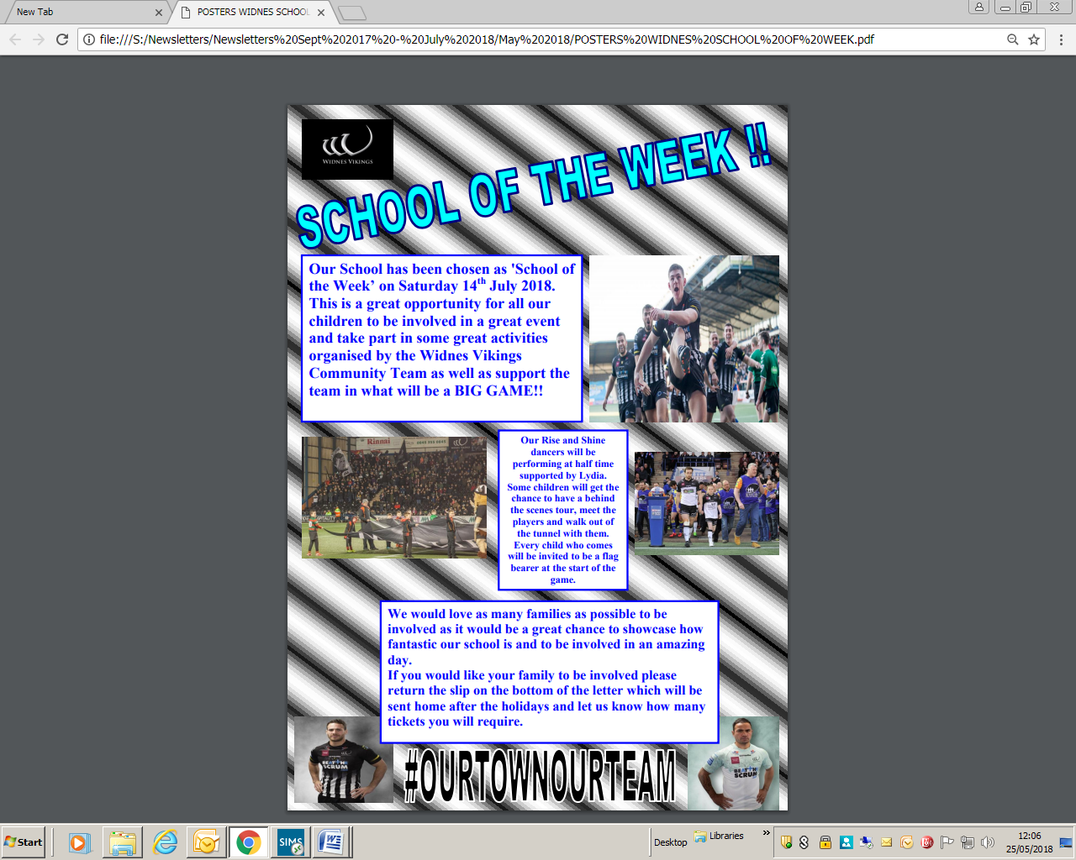

|  |  |
| --- | --- |
| **Diary Dates** | |
| **July** | |
| Tuesday 3rd | Rockpool Experience – Reception, Y1 & Y2 |
| Tuesday 3rd | Halton Poetry Festival 5.30pm St Bede’s Junior School |
| Wednesday 4th | Children’s University celebration |
| Wednesday 4th | Reception class’ visit to Widnes Vikings Dementia Cafe |
| Thursday 5th | Widnes Tennis Academy Taster Day |
| Friday 6th | Orders for Reception Class & Y6 photographs |
| Friday 6th | Free raffle ticket for donations of home made cakes |
| Friday 6th | Family Fun Night 6pm |
| Monday 9th | Y5 children to attend Sts Peter & Paul @ 8.30am |
| Monday 9th | Y6 Football |
| Wednesday 11th | Reception and Y1 trip to Imagine That, Liverpool |
| Thursday 12th | Parent Meetings |
| Friday 13th | Y6 Trip to Gulliver’s World |
| Friday 13th | Reception Rejoice @ 1.45pm |
| Friday 13th | All After School Clubs Finish |
| Saturday 14th | My First Game -Widnes Vikings |
| Monday 16th | Y5 Football |
| Tuesday 17th | Y6 Play |
| Thursday 19th | Y6 Assembly @ 9.15am |

