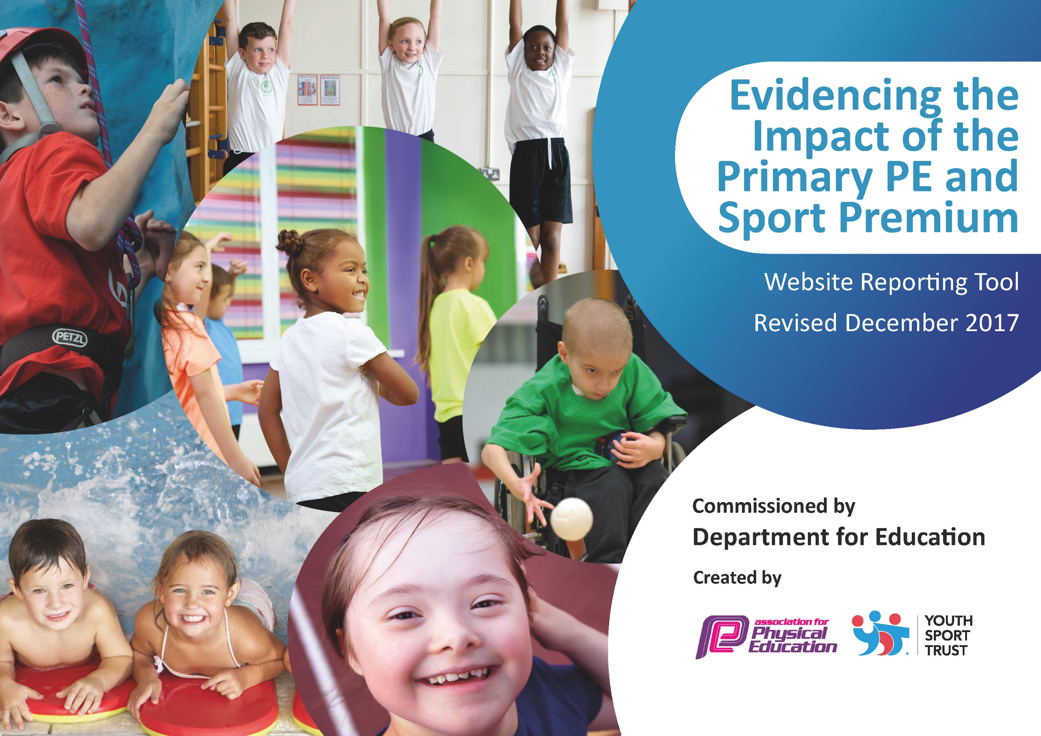

Schools must use the funding to make additional and sustainable improvements to the quality of PE and sport they offer. This means that you should use the Primary PE and Sport Premium to:

- develop or add to the PE and sport activities that your school already offers
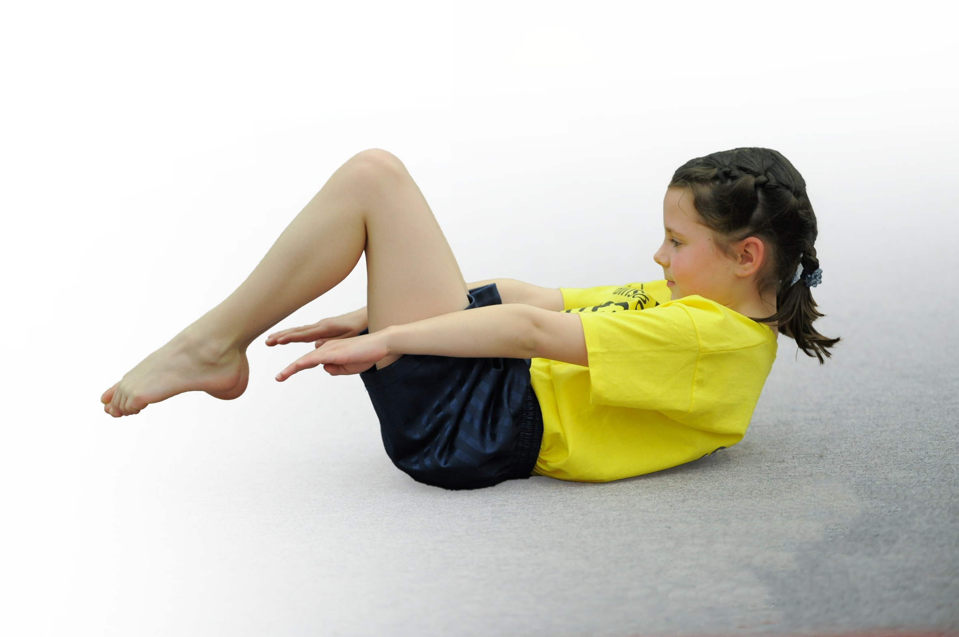
- build capacity and capability within the school to ensure that improvements made now will benefit pupils joining the school in future years

Schools are required to publish details of how they spend this funding as well as on the impact it has on pupils’ PE and sport participation and attainment.
We recommend regularly updating the table and
publishing it on your website
as evidence of your ongoing
review into how you are using
the money to secure maximum, sustainable impact.
§
Support for review and reflection - considering the 5 key indicators from DfE, what development needs are a priority for your setting and your students now and why? Use the space below to reflect on previous spend, identify current need and priorities for the future.

Key achievements to date: | Areas for further improvement and baseline evidence of need:
We have been able to use our Sports funding for another year to help secure our participation in the Knowsley school competitions; we have recently received the Sainsbury’s Gold Award for school games for the third year running.  Continued employment of two sports coaches for a third year to help in the delivery of PE lessons, sports competitions and a range of extra-curricular activities, before and after school hours. | Increase the level of participation for SEND children in school based competitions and competitive competitions.  Introduce PE leaders for all Key Stage 2 classes, with the introduction of Y2 PE leaders in January 2019, to help in the assistance of the PE curriculum. Children will also work on the 3 school values of respect, responsibility and resilience.

Meeting national curriculum requirements for swimming and water safety | Please complete all of the below*:
What percentage of your current Year 6 cohort swim competently, confidently and proficiently over a distance of at least 25 metres? | 97% (29 out of 30 children)
What percentage of your current Year 6 cohort use a range of strokes effectively [for example, front crawl, backstroke and breaststroke]? | 97% (29 out of 30 children)
What percentage of your current Year 6 cohort perform safe self-rescue in different water-based situations? | 40% (12 out of 30 children)
Schools can choose to use the Primary PE and Sport Premium to provide additional provision for swimming but this must be for activity over and above the national curriculum requirements. Have you used it in this way? | No
*Schools may wish to provide this information in April, just before the publication deadline.

Action Plan and Budget Tracking
Capture your intended annual spend against the 5 key indicators. Clarify the success criteria and evidence of impact that you intend to measure to evaluate for students today and for the future.

Academic Year: 2018/19 | Total fund allocated: £18,000 | Date Updated: September 2018
Key indicator 1: The engagement of all pupils in regular physical activity – Chief Medical Officer guidelines recommend that primary school children undertake at least 30 minutes of physical activity a day in school
School focus with clarity on intended impact on pupils: | Actions to achieve: | Funding allocated: | Evidence and impact: | Sustainability and suggested next steps:
Children to complete two hours of PE each week to develop a love of Sport and being active. | Sports coaches to train PE leaders to support children in delivering activities in PE lessons, playtime and lunchtime.  Children to be actively playing for 30 plus minutes each day to improve health and wellbeing.  All children will participate in a planned Sports Day in May 2019, showcasing their sporting talents and competing against their peers.  Due to the success of the Game Changer breakfast club last year, school staff will continue this on a Monday morning, teaching the children the importance of a healthy breakfast and regular exercise.  The PE team will complete an audit of PE resources and purchase new items to help in the delivery of creative PE lessons.  New implementation of the iPE planner. | £12,200 (50% of the wages cost for 2 staff)  NA  NA  £12,200 (50% of the wages cost for 2 staff)  Sports Funding to purchase new PE resources  £1,200 for a 3 year licence. | PE leaders will develop their engagement and confidence in the lessons. They can share their knowledge with their peers and younger children in the school. This will be added to Y2 during the Spring term of 2019.  The participation of children playing in organised activities during break time and lunch time will be more structured, decreasing incidents of poor behaviour and low levels of activity from the children.  Parents will be invited to the Sports Day to help motivate their child and participate in celebrating in their sporting achievements.  By completing the Game Changer sessions, children should have a good understanding of the need for healthy food to fuel their body whilst understanding the need for regular exercise.  Staff will use the new resources in both PE lessons and ex-curricular activities to enhance the sessions. SQ to order new PE mats, benches, tackle mats, balancing and co-ordination equipment and pummel horse equipment for gymnastics.  SQ to train all staff on how to use the new iPE planning, which is located online. Staff will also have access to online assessment tools for the reporting of the children’s skills in PE. | School leaders will be able to train the next set of PE leaders, showcasing the leadership skills which they have developed.  Continue with the development of the school playground focus, looking at the possible installation of a MUGA for school games.  Sustainable activity which happens each year. There is also time to rearrange the Sports Day due to bad weather when it is held in May, with the opportunity to complete during June / July if needed.  Game Changer sessions should help to promote a healthy active lifestyle, which children will continue to develop through a balanced diet and regular sport.  PE lessons can continue to run efficiently and the children’s level of activity should increase as they have more resources to make the lessons more active. Children are able to develop their skills from the previous year, building up their level of development.  The new PE planning can be implemented this year with the embedding of the new scheme over the next 2 years. SQ will continue to support staff through any necessary CPD on how to use the planning / assessment tools with their own cohort.

Key indicator 2: The profile of PE and sport being raised across the school as a tool for whole school improvement
School focus with clarity on intended impact on pupils: | Actions to achieve: | Funding allocated: | Evidence and impact: | Sustainability and suggested next steps:
Promote the use of sport outside the PE lesson. | Children to continue complete a daily mile during the day to help impact upon their health and wellbeing in the school day.  PE display to be regularly updated to show progress in competitions and success in PE lessons.  Level 2 coaches (BW / MT) to continue to provide a wider range of After School and Lunchtime activities for each class.  Training of children in Y3-Y6 Sports Leaders to lead half termly intra-school (Level 1) House competitions during lunchtimes with BW / MT. The PE leaders will also help to support the training of Y2 PE leaders, who will undertake their role in January 2019.  SQ to introduce active numeracy / literacy 3 minute sessions to staff which they can use to help promote physical literacy / numeracy. | NA  NA  £12,200 (50% of the wages cost for 2 staff)  NA  NA | Children are further developing their skills in running and are becoming more competent at running for a greater distance, without the need to stop and rest.  Regular discussion of PE lessons and competitions to promote active lifestyles.  To provide children with the opportunity to develop their social, communication and organisation skills through leadership roles in PE and school sport.  To support staff to develop Level 1 intra school competitions (e.g. house events) within school.  Children will be able to take active ‘rest’ sessions in their learning, which will have a positive impact on their listening, attention and concentration. | Daily Mile can be completed in all weathers, so children will be able to develop a love of running and build up their skills.  BW / MT to update the PE board with updates and photographs from competitions, helping to promote the successes of our children. This should encourage other children to participate in competitions.  Incidents at play time and dinner time should decrease due to a focus on structured activities, led by PE leaders.  All children are actively engaged in the running of school competitions and are seeking out opportunities to involve and motivate their peers.  Staff will be able to use these short sessions as and when they require, so they are sustainable throughout the school day, alongside the running of the Daily Mile.

Key indicator 3: Increased confidence, knowledge and skills of all staff in teaching PE and sport
School focus with clarity on intended  impact on pupils: | Actions to achieve: | Funding  allocated: | Evidence and impact: | Sustainability and suggested  next steps:
Improved quality of children’s physical education for all children. | Children to participate in pupil consultations with the Student Council in the autumn term, and with SQ during the spring term. They will explain what they enjoy about the lessons and how actively engaged they feel in the running of each session.  PE team to complete a scrutiny of planning and evaluations, looking to see if the children are working from a broad and balanced curriculum and how they are progressing in their learning.  CPD for PE coordinator with the Knowsley SSP staff and surrounding cluster schools.  CPD for BW / MT to attend Inclusive PE training and Outstanding Dance lessons.  Monitor the level of participation at the before school and after school clubs, referring to the Children’s University data.  Encourage children with SEND to take part in more competitions outside of school. | NA  NA  £1,200 SLA with Knowsley SSP  £1,200 SLA with Knowsley SSP  £900 SLA with Enrich Education  £1,200 SLA with Knowsley SSP | PE team and Student Council can analyse the responses from the children and use them as action points for the summer term’s lessons and break / lunch time activities.  All children should be working on the new iPE planning, which shows a development of skills across KS1 and KS2. The assessment data will show the progress in children’s attainment in their PE lessons.  PE coordinator can filter information with all staff to help improve the teaching of PE and upskill the 2 NQTs.  BW / MT can filter information with all staff to help improve the teaching of PE and upskill the 2 NQTs.  An analysis of the Children’s University data for ex-curricular clubs can highlight children who do not attend sporting clubs, which staff can then use to promote activities to the children to improve their health and fitness.  We will increase the level of SEND competitions for the year and encourage all children with SEND to participate during break / lunch time activities when there is opportunity for all children to play competitively. | Actions from the pupil consultations can be shared with staff and addressed through future PE lessons.  SQ will monitor the progress of the children’s attainment in PE at the end of term 1b, which will then impact upon the spring term’s lessons.  Staff will be more confident and competent at developing their own PE sessions and teaching the skills to the children.  Any children who are not participating in extra-curricular activities can be targeted through the Children’s University data, and we can target them in the allocation of after school club places.  The PE leaders can structure their own games and use this to develop competitive sport with their peers in an informal way.

Key indicator 4: Broader experience of a range of sports and activities offered to all pupils
School focus with clarity on intended  impact on pupils: | Actions to achieve: | Funding  allocated: | Evidence and impact: | Sustainability and suggested  next steps:
To enable children to find a sport, exercise or game which they enjoy and will participate in regularly; this will increase their physical fitness. | Book specialist coaches to deliver a wide range of sports to enhance the PE curriculum.  All children in Y5 and Y6 will have the opportunity to participate in Outdoor and Adventurous activities, through a 3 day residential to Robinwood, The Old School or Robinwood, Cross Lanes.  Participation in an increased range of Inter-School (Level 2) Competition with Knowsley SSP.  Audit of current sports equipment and purchase of new equipment that is appropriate for all children and supports a range of activities across the school.  Children in Y3 / Y4 to complete a block of 16 hours swimming lessons at Halewood Leisure Centre during the spring term.  Children in Y5 / Y6 to complete a 2 hour swimming assessment at Halewood Leisure Centre during term 1b.  Promote a healthy mind and wellbeing for all children through the use of meditation and yoga. This will be completed during Mental Health awareness week which is such an important priority for all children and adults. | Approximately £1,200 with a donation from the PTFA  £1,200 SLA with Knowsley SSP  £800 SLA with Halewood Leisure Centre  £200 for the hiring of the pool for 2 hours.  £175 for whole day activities with Kids Love Yoga | The number of children in sporting clubs will increase, which will be noted on the Children’s University data.  Children will build on their teamwork, resilience and adventurous activities throughout the 3 day residential course. This will provide a boost to the health and wellbeing, which can be transferred across other curriculum areas.  PE coordinator will promote the Level 2 competitions for all children to compete in and the successes of these activities will be shown via the school newsletter, assemblies, PE board and Twitter account.  Children will have more resources to use in lessons to help them develop skills and increase participation in lessons.  Children will develop their swimming skills by being able to swim 25m, using a variety of strokes. They should also work on their lifesaving skills to aid them in a swimming emergency.  Children to be assessed on their swimming skills by being able to swim 25m, using a variety of strokes. They should also work on their lifesaving skills to aid them in a swimming emergency.  Children will develop their knowledge of how important it is to be aware of their own mind and how relaxation techniques can help to regulate their breathing and relax their bodies. | If clubs are proving to be popular, we can continue these clubs and possibly increase the number of sessions for the children.  Children will develop their teamwork skills and an increase of positive wellbeing should be transferred into other areas of the curriculum, after the residentials.  Children in Y5 / Y6 who have not yet developed the ability to swim the national requirement may have the opportunity to develop these skills further in the summer term.  The breathing techniques and yoga moves can be used as cool down methods for all PE lessons. Children can use these techniques to help in the development of their own health and well-being to calm them down in times of stress or anxiety.

Key indicator 5: Increased participation in competitive sport
School focus with clarity on intended  impact on pupils: | Actions to achieve: | Funding  allocated: | Evidence and impact: | Sustainability and suggested  next steps:
Increase the range of competitions for children with SEND, showing an inclusive range of competitions for all children. | SQ to work with BW / MT and identify children with SEND who would benefit from selection for the SEND competitions.  PE coordinator will attend regular meetings with the Knowsley SSP partnership and wider school groups led by the Schools Games Organiser.  Inter-school (Level 2) competitions with Cronton C of E for football, rugby, netball and cross-country. | £1,200 SLA with Knowsley SSP  £1,200 SLA with Knowsley SSP  NA | SEND children will continue to feel more involved in school competitions, which should improve their health and wellbeing across other curriculum areas.  An increase in the level of competitions and the variety of competitions, when compared to previous years. We have received the Sainsbury’s School Games Mark of Gold for the third year in a row due to the high level of competitions which we participate in.  All children will have access to competitive sport, whether this is through A or B teams. | Continue the participation of SEND children in competitions, as it will help to aid their involvement in all aspects of the curriculum, giving them a great boost in their self-esteem. Children are currently completing Kurling, Boccia and Orienteering. The children will be encouraged to participate in all break / lunch time activities each day too.  PE co-ordinator can feedback any information from the meetings with BW / MT and all staff via staff meetings.  BW / MT to continue to develop our good link with Cronton C of E for the arrangement of inter-school competitions, to continue a high level of inclusive sport for all children.

