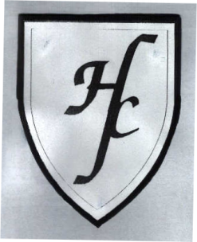
Holy Family Catholic Primary School
Hall Lane, Cronton, Cheshire WA8 5DW

Tel: 0151 424 3926 Fax : 0151 420 3177

Headteacher : Mrs J Cook-Hannah

We pray together. We play together. We learn together.

Dear Parents / Carers,

Hello everyone, another busy week at Holy Family both in Reception and Year One. We have been busy solving the mystery of the naughty dinosaurs this week which I am sure you’ve heard about! If you haven’t, we have had some visitors this week in our Reception and Year One class who have been causing mischief in the night.

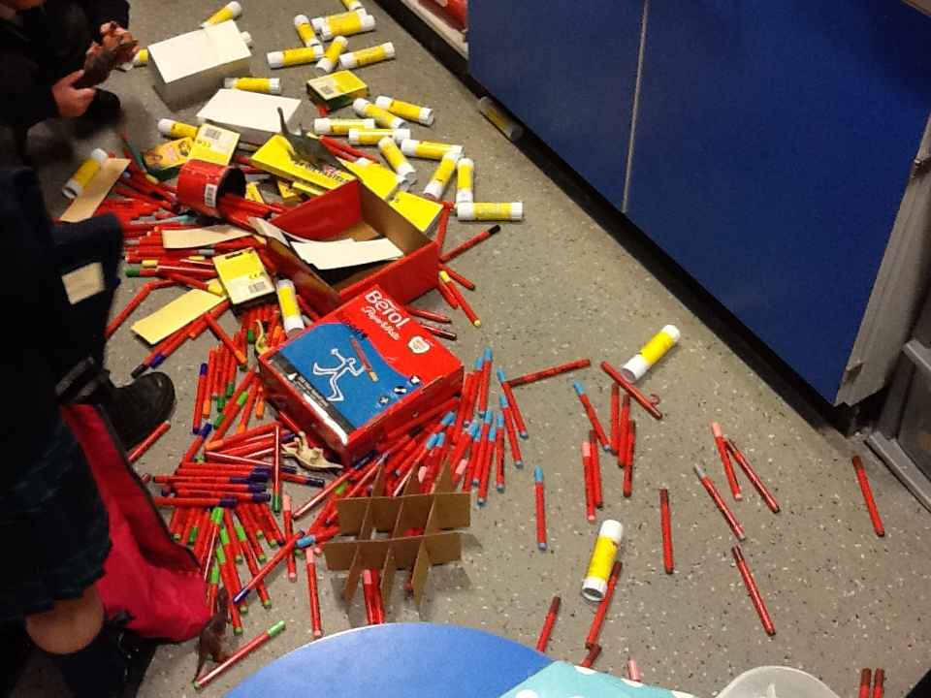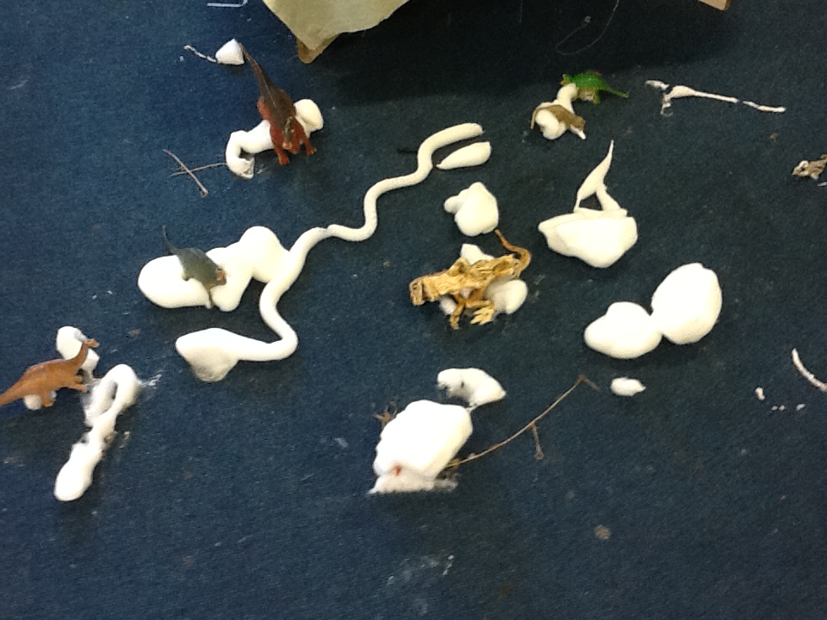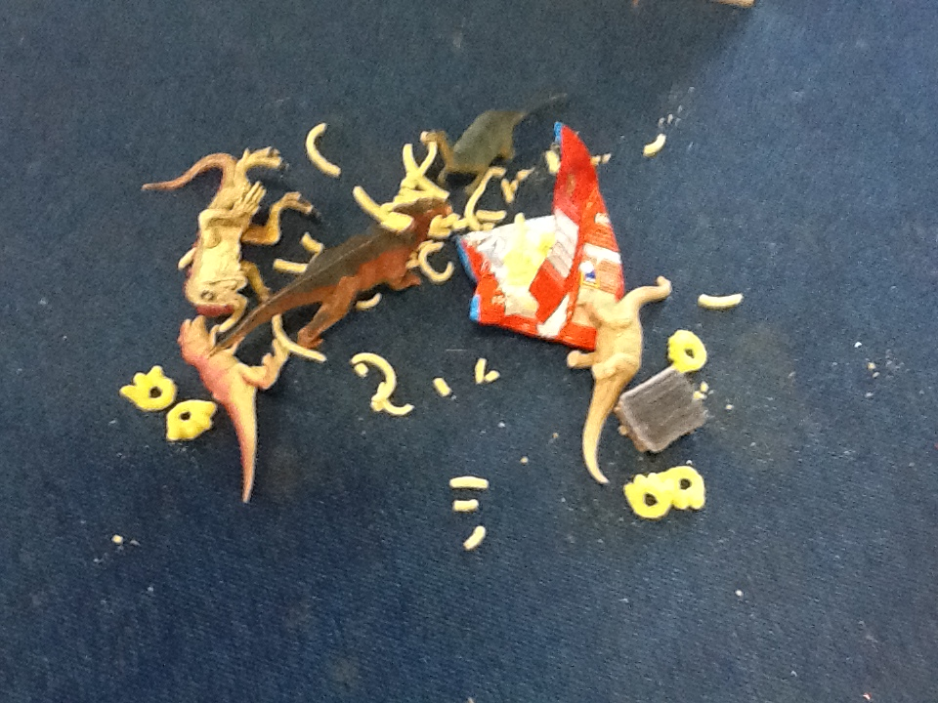

Literacy
We started the week reading Harry And His Bucket Full Of Dinosaurs which we enjoyed. Then we shared facts about what we knew about dinosaurs and talked about where we could find out information about things we wanted to find out. We have had great fun trying to make a plan to catch the naughty dinosaurs in the act who have been making a mess in our classroom all week!

Maths
This week we have been talking about properties of 2D shapes and have been shape spotting both inside and outside. We have answered questions like ‘Which shapes are similar?’ and ‘What makes a triangle a triangle?’. Maybe this weekend you can see if you can spot some shapes in your house or as you are out and about this weekend.

2Simple
If for some reason you are not receiving 2Simple emails please let us know. We hope you are enjoying looking at the children’s learning stories.

Homework
Many apologies for last week’s homework mix up. Thank you to those of you who sent in stories or had written down some number sentences. This week the homework will be to complete Unit 1, Week 3, Lesson 1 (page 10) of the homework book and then to choose one other page to complete – either page 11, 12 or 13.

Come and See
Please bring in family photos for the children’s Come and See board.

Letters and Sounds
This week we have been reading sentences that have featured the sounds we have been revising in Phase 3. When you are reading your RARA books with your child, try and see if they can spot a digraph (a sound that is made up of 2 letters e.g ow) or a trigraph (a sound that is made up of 3 letters e.g. igh).

My email
Please continue to contact me via holyfamilycron@knowsley.gov.uk
Any responses to 2Simple can be sent to Mrs Evans’ address. Many thanks for your patience with this and for those of you who have emailed me this week.

Jumpers/Cardigans
Please remind your child to put their jumpers and cardigans on their pegs and in their book bags at the end of the day if they do not wish to wear them home. This will reduce the number of lost jumpers and cardigans each day. Many thanks.

Behaviour/Values
Please continue to talk about our values with your child, particularly ‘listen’ which we have had to talk about a lot this week.

School Trip
As mentioned in my last letter everyone who asked for a ticket to come to the Brindley has been accommodated. Unfortunately we do only have 10 places on the coach which means eleven parents will need to make their own way. A letter is attached saying if you have been selected to come on the bus or if you will need to make your own way.

Outdoor Classroom
Do you know anyone who is a keen gardener, who might be interested in spending an hour every week working alongside our children and supporting them in the up keep of our classroom garden in the outdoor classroom. We have lots of flower beds and growing areas that need to be looked after by a green fingered person. Please let me know if anyone is interested.

Coffee Morning
A reminder that on Tuesday 30th September at 2.15pm we are having our coffee morning and that cakes and raffle prize donations are welcome. We look forward to seeing you there and I am really looking forward to meeting you all properly.

Thank you for your continued support,

Mrs Mitchell and Miss Cook

